**Input and output data description of STALite (macro and meso level network):**

**The main changes in this version are:**

1. **[Meso_network_generator] Macro to meso level network changes (add movement links to the meso network from macro ones)**
2. **[SignalAPI] Add signalized intersections to the simulation function (automatically generate cycle length and green duration of each intersection)**

**Input and output (Changes highlighted in yellow)**

|  |  |  |  |  |
| --- | --- | --- | --- | --- |
| **Input**  **/Output** | **File Category** | **File Names** | **Data Source** | **More details** |
| Input files | Configuration File | settings.csv | Self-defined | Set the number of iteration and the mode of assignment. Add more inputs for signalized simulation |
| Network inputs | node.csv | Transformed from shapefile or other source | Define nodes in the network |
| road_link.csv | Transformed from shapefile or other source | Define links in the network, including parameters used in Volume-Delay Function (VDF) ~~and Resource Utilization Constraint (RUC).~~ |
| movement.csv | Transformed from shapefile or other source | Define the movement allowed in each intersection |
| link_type.csv | Self-defined | Define types of links in the network. Each type of link could have specific agent types, except which agents of other types cannot use links of this type.  Add traffic_flow_code to define the queueing models. |
| link_performance.csv | RITIS, SHA or others for count and speed data | Utilize the time-dependent real word data to calibrate the parameters with BPR-X function for links |
| Demand inputs | demand_file_list.csv | Self-defined | Define demand type, period, and agent type. |
| demand.csv | Aggregated form LBS trips or from other models | Could have multiple files of each time period (peaks and off-peaks). Two demand types of passenger and vehicles. |
| demand_period.csv | Self-defined | Define the simulation periods: start and end time of the peak and off-peak time |
| agent.csv | Initial agents now will come from the simulation with OD matrix. Later on this could also come from AI-driven behavior modeling. | After every round of simulation the file will be overwritten. The agent file will also serve as the connection with behavior models.  Each row represents one set of agents sharing the same attributes instead of one particular agent.  Agent file will serve as the standard format between different simulation engines in different resolution networks. |
| agent_type.csv | Self-defined | Define attributes of each type of agent, including VOT (unit: dollar per hour), PCE and CRU of each type of link. |
| Output files | Output agents | agent.csv | From simulation | Overwrite the input data and will serve as the new input of the next round of simulation.  Show the results of the assignment, including the volume, cost, travel time and distance of each path of each agent, as well as the link sequence and time sequence. |
| Output link performances | link_performance.csv | From simulation | Overwrite the input data and will serve as the new input of the next round of simulation.  Show the performance of each link, including the travel time, total volume, volume for different agent types, and resource balance. |
| Output link performance of the movement links | link_performance_sig.csv | From simulation | Similar to link_performance file but only for movement links. |
| Singal representations | Service_arc.csv | From simulation | Generate the green duration of each service arc (the movement link) |

**Detailed data format (Changes highlighted in yellow):**

#### **settings**

|  |  |  |
| --- | --- | --- |
| **Field Name** | **Description** | **Sample Value** |
| number_of_iterations | The iteration number for basic assignment | 20 |
| assignment_mode | Assignment_mode = 0: only output link performances; Assignment_mode = 1: output link performances and agent files (Using method of UE: user equilibrium); Assignment_mode = 2: output link performances and agent files (Using method of SO: system optimization); Assignment_mode = 3: output link performances and agent files (Using method of path resource constraint); | 0/1/2/3 |
| column_updating_iterations | Iterations for re-assignment | 5 |
| signal_updating_iterations | The iteration number of starting performing the signal timing updating | 2 (should between 1-number_of_interations, can’t be 0) |
| signal_updating_output | The iteration number when output the signal results on screen | 20 (usually same as the number of iterations) |

#### **demand_file_list**

|  |  |  |
| --- | --- | --- |
| **Field Name** | **Description** | **Sample Value** |
| scenario_no | Scenario number | 0 |
| file_sequence_no | Sequence number of input file | 1 |
| file_name | Name of input demand files | demand.csv |
| format_type | Input demand format | column: OD matrix |
| demand_period | Demand period name | AM |
| agent_type | Demand agent type | p |

#### **demand_period**

|  |  |  |
| --- | --- | --- |
| **Field Name** | **Description** | **Sample Value** |
| demand_period_id | The id of each demand period | 1 |
| demand_period | Name of demand period | AM, PM |
| time_period | Time range of each demand period | 0600-1100 |

#### **demand**

|  |  |  |
| --- | --- | --- |
| **Field Name** | **Description** | **Sample Value** |
| O | Origin zone id | 1 |
| D | Destination zone id | 2 |
| value | Volume from O to D | 20.3 |

#### **node.csv**

|  |  |  |
| --- | --- | --- |
| **Field Name** | **Description** | **Sample Value** |
| name | Optional for visualization only | Main street @ Highland Dr. |
| node_id | Node identification number (primary key) | 1001 |
| controp_type | Intersection control type (label it should be signalized or not) | 5 |
| node_type | Optional text label for visualization and identifies of node | 1 |
| x_coord | Longitude or horizontal coordinate in any arbitrary geographic coordinate system. | 30.00 |
| y_coord | Latitude or vertical coordinate horizontal coordinate in any arbitrary geographic coordinate system | 76.00 |
| geometry | Text string used to describe node location https://en.wikipedia.org/wiki/Well-known_text_representation_of_geometry | POINT (30 10) |
| zone_id | **Only zone centroid will have zone id** | 1 |

#### **Movement.csv (only need for macro network to generate movement links in meso network). This defines in each signalized intersection how is the turning movement should be.**

|  |  |  |  |  |
| --- | --- | --- | --- | --- |
| **Field Name** | **Type** | **Required** | **Description** | **Sample Values** |
| mvmt_id | Movement_ID | Required | Primary key | 1 |
| node_id | Node_ID | Required | Foreign key (from Nodes table) | 135 |
| name | TEXT | Optional |  |  |
| ib_link_id | Link_ID | Required | Foreign key (from Road_link table) | 89 135 (from node to node,) |
| ib_lane | INTEGER | Optional | Uses lane number | 1|2|3 (if it is 1,2,3 list all of them; should same as ob_lane) |
| ob_link_id | Link_ID | Required | Foreign key (from Road_link table) | 135 136 |
| ob_lane | INTEGER | Optional | Uses lane numbers or ranges of numbers | 1|2|3 (if it is 1,2,3 list all of them) |
| type | TEXT | Required | Direction+turning movement | SBL, SBT, SBR |
| penalty | INTEGER | Optional | Turn penalty (seconds) |  |
| capacity | INTEGER | Optional |  |  |
| ctrl_type |  | Optional | No Control, Stop, Yield, Signal, etc. |  |

#### **road_link.csv**

|  |  |  |
| --- | --- | --- |
| **Field Name** | **Description** | **Sample Values** |
| name | Optional for visualization purposes | Main Street |
| road_link_id | Link identification number of the road (primary key) | 101 |
| from_node_id | Upstream node number of the link, must already defined in input_node.csv | 2 |
| to_node_id | Downstream node number of the link, must already defined in input_node.csv | 3 |
| facility_type | Optional text label for visualization and data checking purposes | 1 |
| length | The length of the link (between end nodes), measured in units of **miles**. | 1.0 |
| lanes | The number of lanes on the link | 2 |
| free_speed | Free-flow speed on a defined link . Suggested Unit: mph or kmph | 20 |
| capacity | The number of vehicles per hour per lane.  **(this should be calibrated with real word data)** | 1500 |
| main_node | Each intersection will share one main node | 1 |
| movement_str | The movement string of each movement link | SBL, NBT |
| geometry | Text string used to describe link shape and location (typically in WKT geographic coordinate system). The initial value can be empty, and NeXTA will generate the text string based on the coordinates of upstream and downstream nodes. | LINESTRING (30 10, 10 30, 40 40) |
| VDF_fftt(n) | Free flow travel time of time period (n) |  |
| VDF_cap(n) | Capacity of time period (n) |  |
| VDF_alpha(n) | Alpha parameter in BPR function of time period (n) |  |
| VDF_beta(n) | Beta parameter in BPR function of time period (n) |  |
| VDF_theta(n) | Theta parameter in BPR function of time period (n) |  |
| VDF_gamma(n) | Gamma parameter in BPR function of time period (n) |  |
| VDF_mu(n) | Theta parameter in BPR function of time period (n) |  |
| ~~RUC_rho(n)~~ | ~~For service network design only (not required for now)~~ |  |
| ~~RUC_resource(n)~~ | ~~For service network design only (not required for now)~~ |  |
| ~~RUC_type~~ | ~~For service network design only (not required for now)~~ |  |

### **Remarks:**

### Fields can be generated or populated by NeXTA:

### geometry fields can be imported from GIS shape files or generated based on the coordinates of upstream and downstream nodes. direction = 1 by default.

### 

#### **agent.csv**

|  |  |  |
| --- | --- | --- |
| **Field Name** | **Description** | **Sample Value** |
| agent_id | Node identification number | 1 |
| o_zone_id | Origin zone number of the agent | 1 |
| d_zone_id | Destination zone number of the agent | 7 |
| o_node_id | Origin node number of the agent | 1 |
| d_node_id | Destination node number of the agent | 20 |
| agent_type | Agent type | p |
| time_period | The simulation time period of the agent | AM |
| volume | Maximum flow rate for each lane on the link, in vehicles per hour | 60 |
| cost | The amount of money/time that agent spend | 360 |
| travel_time | The total time from the origin to the destination of the agent | 360 |
| distance | The total travel distance from the origin to the destination of the agent | 22 |
| opti_cost | Optimal cost |  |
| oc_diff | Difference between current to optimal cost |  |
| relative_diff | Relative gap value for converge purpose |  |
| node_sequence | The nodes through which agents pass in turn |  |
| link_sequence | The links through which agents pass in turn |  |
| time_sequence | Time sequence to pass the nodes |  |
| time_decimal_sequence | Time sequence in decimal |  |

#### 

#### **link_performance.csv (output file no need to change, generate automatically)**

|  |  |  |
| --- | --- | --- |
| **Field Name** | **Description** | **Sample Values** |
| road_link_id | Link identification number of the road, with direction | 10420 |
| from_node_id | The start node ID of the link | 12577 |
| to_node_id | The end node ID of the link | 12653 |
| time_period | The category of the time_period, self-defined peak and off-peak hours | 0600_1100 |
| volume | The volume passing through the link during the time_period, in 15 minutes | 8 |
| capacity | The lane capacity (or link?) | 2904 |
| speed | The average speed passing through the link during the time_period | 23.4 |
| VOC | Volume over capacity rate | 0.8 |
| notes | Some explanatory text | period-based |

#### **Service_arc.csv (output file no need to change, generate automatically)**

|  |  |  |
| --- | --- | --- |
| **Field Name** | **Description** | **Sample Values** |
| road_link_id | Link identification number of the road, with direction | 10420 |
| from_node_id | The start node ID of the link | 12577 |
| to_node_id | The end node ID of the link | 12653 |
| time_window | Time window of green time of this movement | 0700:20_0700:31 |
| time_interval |  |  |
| travel_time_delta |  |  |
| capacity |  |  |
| cycle_no |  |  |
| cycle_length | Cycle length of the signalized node |  |
| green_time | Green duration |  |
| red_time | Red duration |  |
| main_node_id |  |  |
| stage | The phase in the NEMA phase plan |  |
| movement_str | Movement string details |  |

How to code signalized intersections

Signalized intersections are represented as movement_links from macro to meso.

* Real-world intersections:

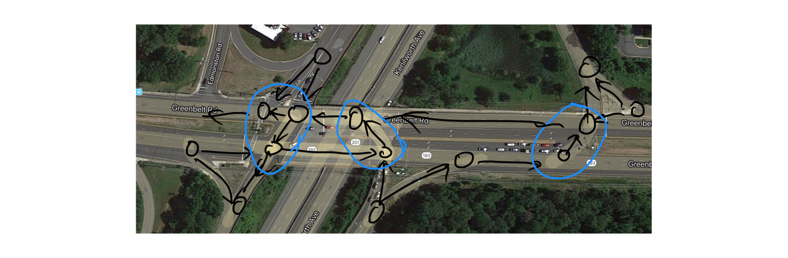

Macro network with movements:

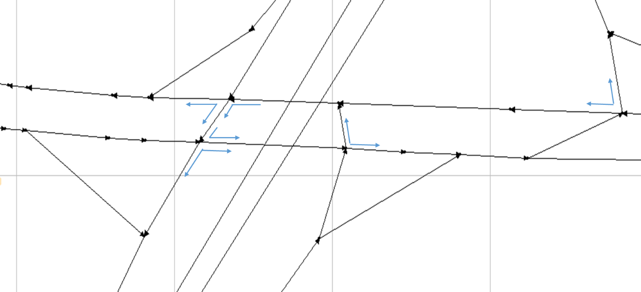

Automatically transformed to meso network for signalization

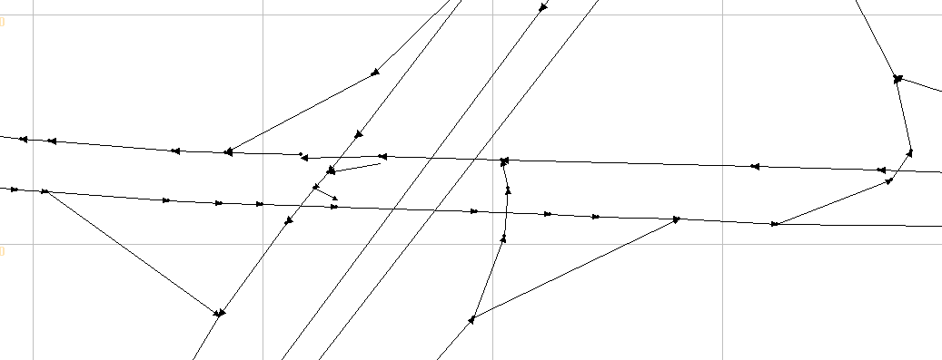

Generate the cycle length of each signalized intersection and green duration for each movement link.

Generate service_arc for each movement_link

For example:



Then run STALite with the service arcs.